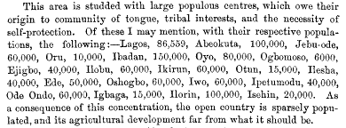

**Ifon (Ondo)**: A polity in the Ondo State ...  
**Ifon (Osun)** : A kingdom in the Orolu Local Government Area (LGA) in Osun State .

Ose is a Local Government Area in Ondo State, Nigeria. Its headquarters are in the town of Ifon.